**SUPPORTING INFORMATION**

Additional supporting information may be found online in the supporting information tab for this article.

**List of information available**

Table 1-SI: Perfusate composition.

Figure 1-SI: study recruitment flowchart

Figure 2-SI: vascular flows during NMP: (A) hepatic artery and (B) portal vein.

Figure 3-SI: IL-6 (A) and IL-10 (B) perfusate concentration during NMP.

Figure 4-SI: electron micrographs of liver samples after cold ischemia storage; (A) swollen mitochondria in hepatocytes from group CS; (B) magnification of the previous panel; (C, D) swollen mitochondria in hepatocytes from group NMP.

Figure 5-SI: electron micrographs of CS liver samples after cold ischemia storage; (A, B) cytoplasmic lipid droplets; (C, D) biliary poles with dense bodies.

Figure 6-SI: electron micrographs of liver samples after cold ischemia storage showing reduced Disse spaces (A: CS liver; B: NMP liver) and non-activated Kupffer cells (C: CS liver; D: NMP liver).

Figure 7-SI: electron micrographs of CS liver samples 2 hours after implantation; (A, B) mitochondrial swelling; (C, D) lipid droplets.

Figure 8-SI: electron micrographs of CS liver samples 2 hours after implantation: (A) numerous dense bodies in the biliary pole; (B) damaged vessel; (C) activated Kupffer cell; (D) infiltrating neutrophil.

Figure 9-SI: electron micrographs of NMP liver samples 2 hours after implantation: (A, B) mitochondria of normal size; (C, D) reduced lipid droplets

Table 1-SI. Perfusate composition.

|  |  |
| --- | --- |
| **COMPONENTS** | **VOLUME** |
| ABO-compatible red blood cells concentrate | 750 mL |
| Gelofusine® (Braun, Melsungen, Germany) | 1000 mL |
| Human Albumin 200 g/L (Albital®, Kedrion, Barga (LU), Italy) | 100 mL |
| Parenteral nutrition (Plusflex®, Braun, Melsungen, Germany) | 10 mL |
| Multivitamins intravenous (IV) solution (Cernevit®, Italy) | 10 mL |
| Metronidazole IV solution 5mg/mL (Baxter, Rome, Italy) | 40 mL |
| Cefazolin 1000 mg (Teva Italia, Milan, Italy) | 10 mL |
| Fluconazole 100 mg (Fresenius Kabi Italia, Verona, Italy) | 50 mL |
| Fast acting Insulin 100 UI/ml (Actrapid®, Denmark) | 20 mL |
| Calcium Gluconate IV solution 10% (Galenica Senese) | 40 mL |
| Sterile water | 50 mL |
| Sodium chlorate 0.9% solution (Fresenius Kabi Italia) | 150 mL |
| Sodium bicarbonate 8.4% solution (Monico, Venice, Italy) | 30 mL |
| Heparin 25,000 units (Epsoclar®, Hospira Italy, Naples, Italy) | 5 mL |
| Total volume | 2265 mL |

**Figure 1-SI.** Study flowchart

**CEFEMA Flowchart Sep. 2016**

Assessed for eligibility (n=83)

September 2016 – April 2017

EXCLUDED (n=15)

* Not meeting transplantability inclusion criteria during pre-transplantation assessment (n=11)
* Refused to participate (n=4)

Randomized in CEFEMA control group. LT with graft from donor > 70 years old after standard cold storage

(n=10)

Randomized in CEFEMA study group. LT with graft from donor > 70 years old after Ex-situ NMP of the graft

(n=10)

## Suitable for enrollment in the CEFEMA Study

**(n=35)**

Excluded (n=33) LT with graft from donor < 70 years old.

## Enrollment (n=68)

September 2016 – April 2017

LT with graft from donor older than 70 years old not randomized in the CEFEMA study because study completed by the time of transplantation (n = 15)

## Allocation

## Follow-Up

Until November 2017

(n=1) death due to fungal sepsis

(n=1) re-LT for graft loss due to hepatic artery thrombosis

**Figure 2-SI.** Vascular flows during NMP: (A) hepatic artery and (B) portal vein.

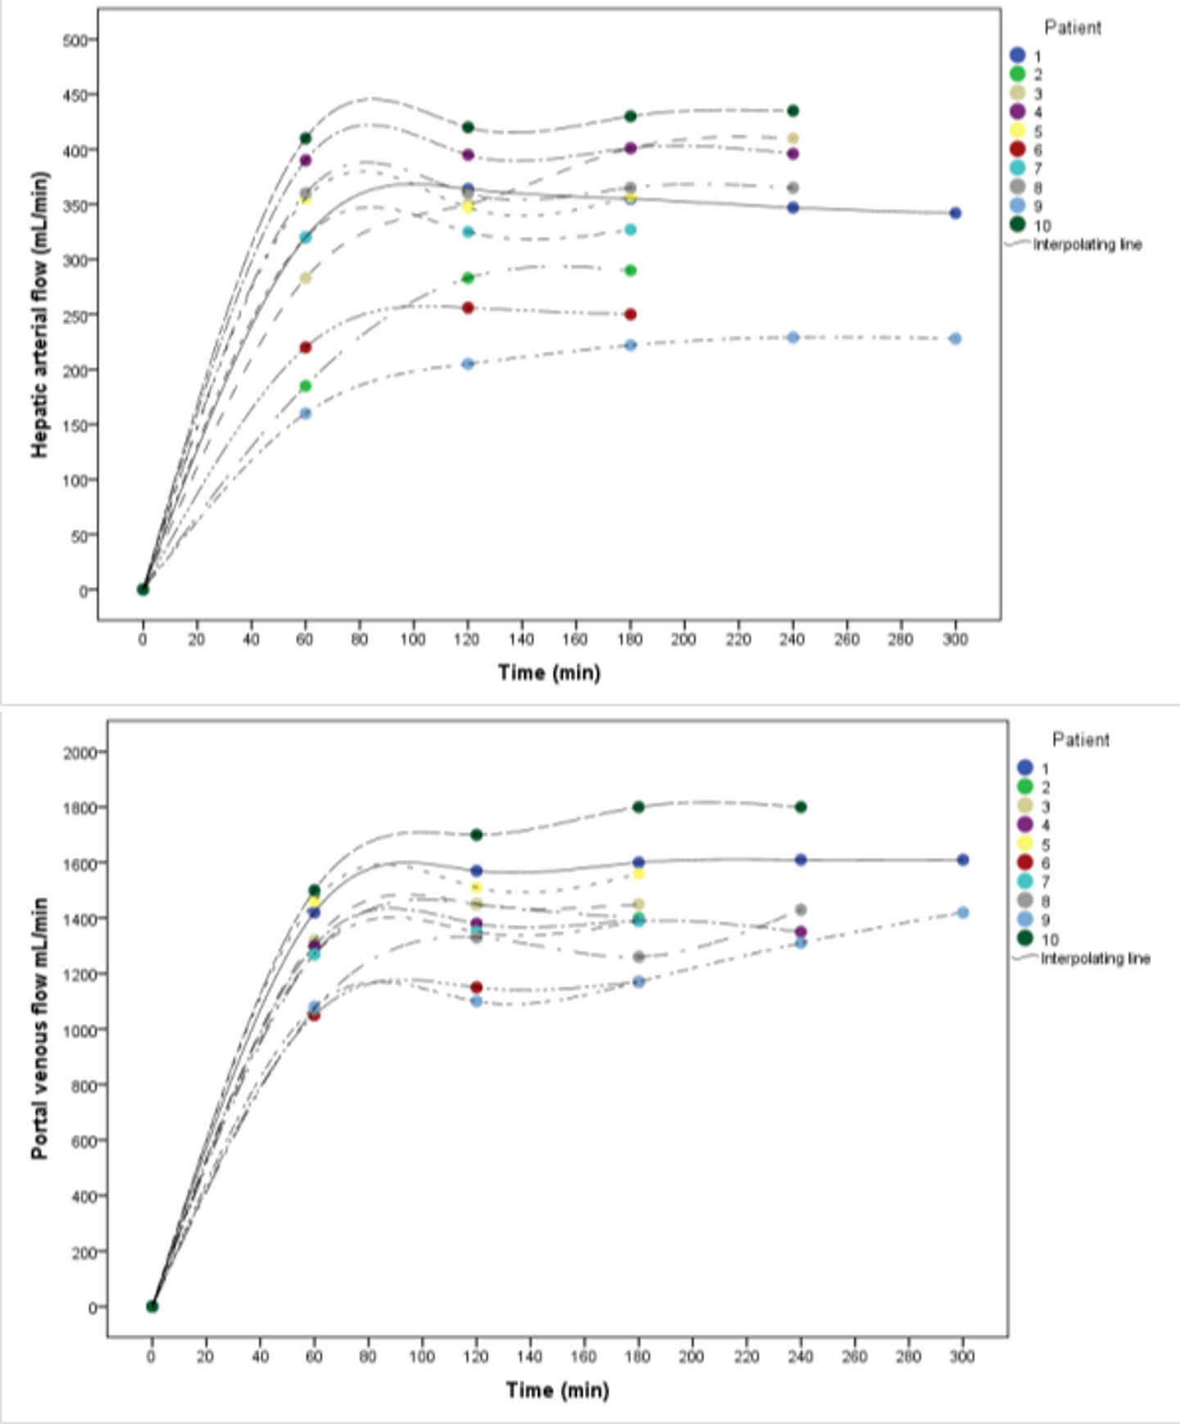

**Figure 3-SI.** IL-6 (A) and IL-10 (B) perfusate concentration during NMP.

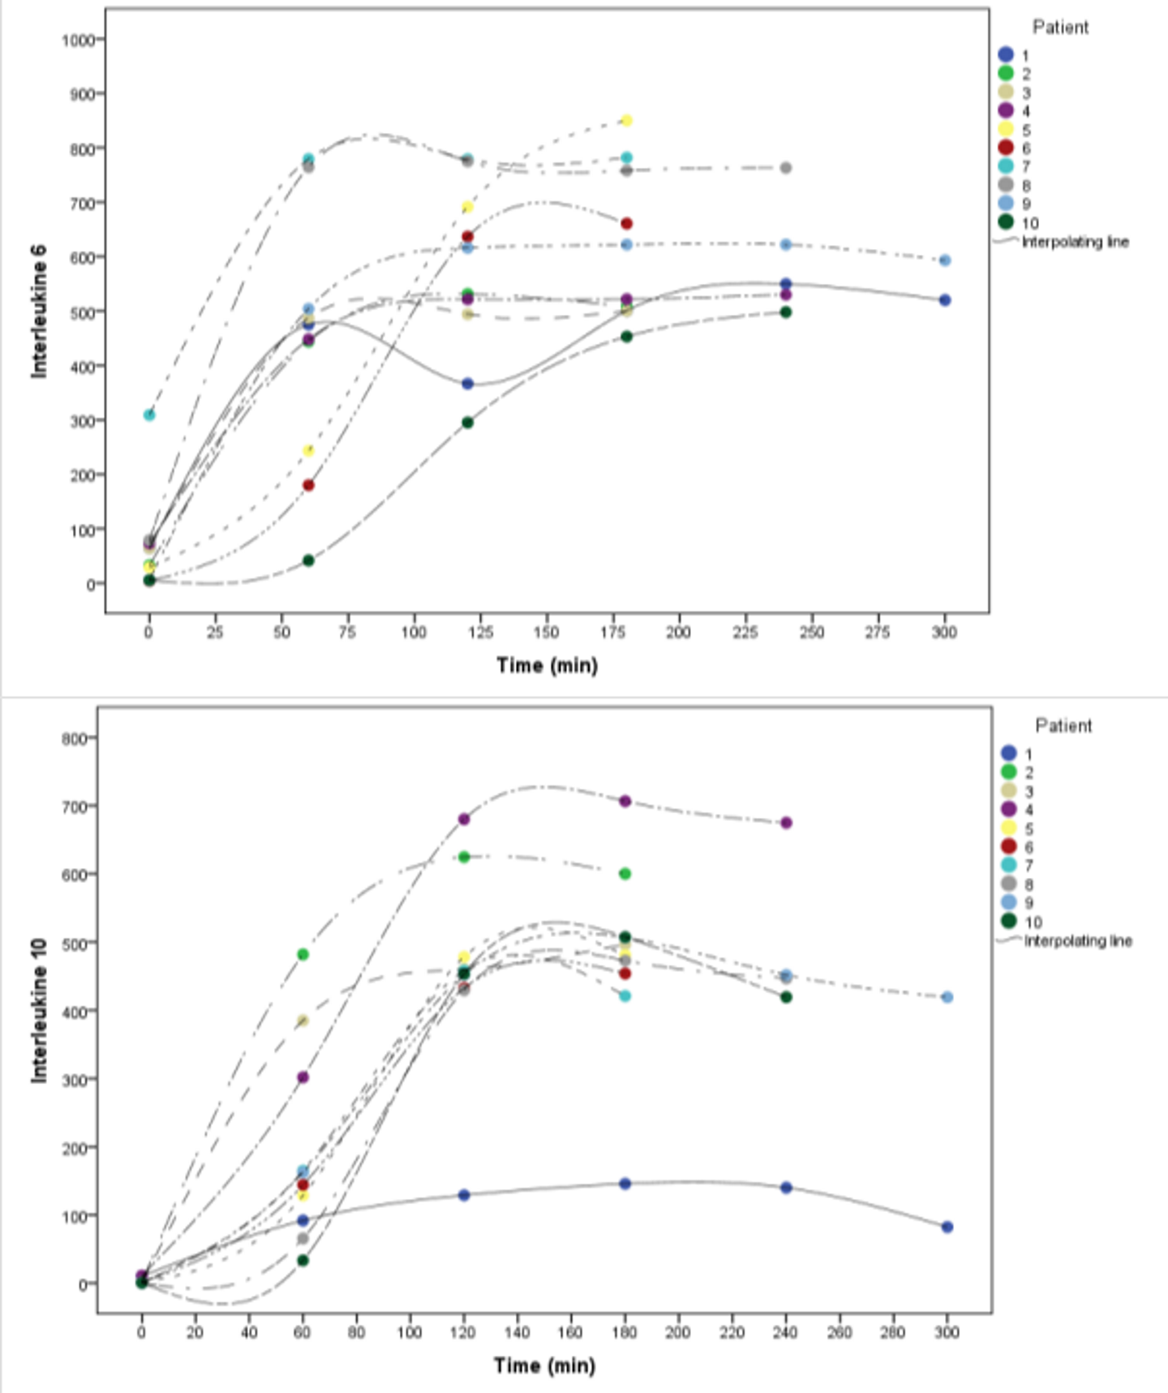

**Figure 4-SI.** Electron micrographs of liver samples after cold ischemia storage. **A)** Swollen mitochondria in hepatocytes from group CS; **B)** Magnification of the previous panel; **C, D)** Swollen mitochondria in hepatocytes from group NMP.

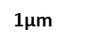 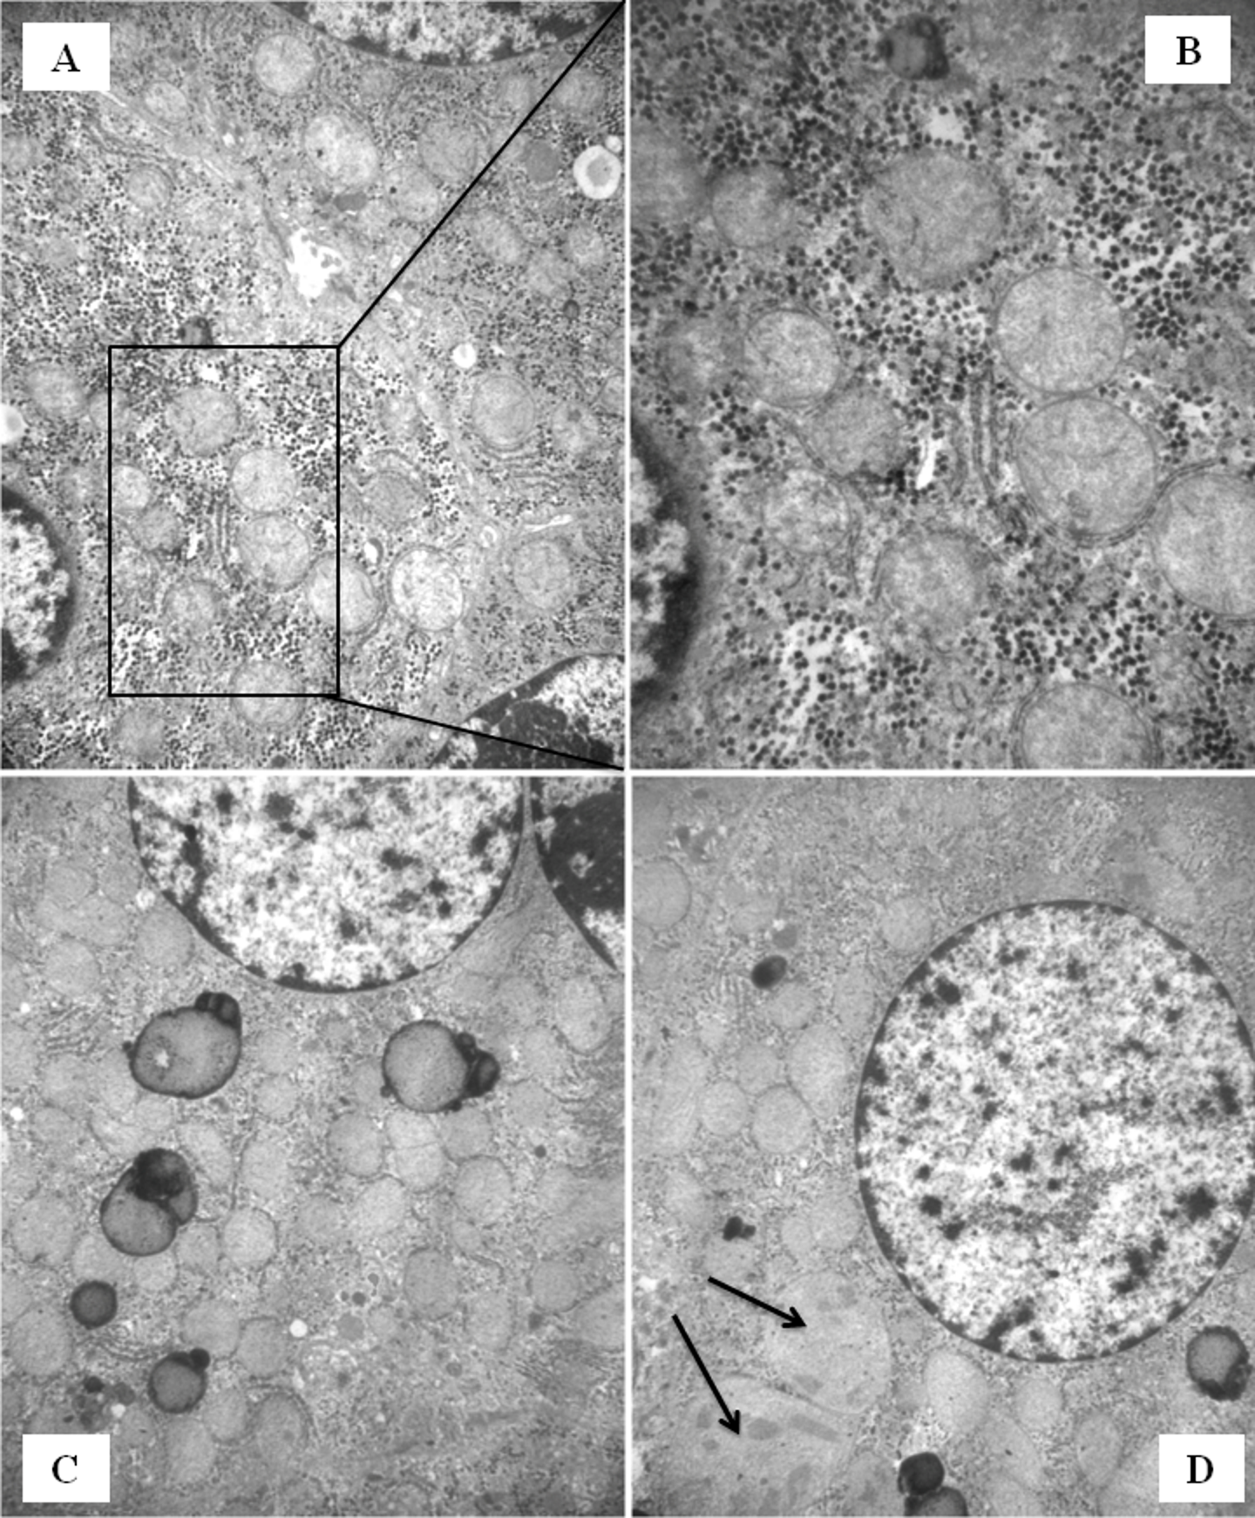

**0,45µm**

**Figure 5-SI.** Electron micrographs of CS liver samples after cold ischemia storage; (A, B) Cytoplasmic lipid droplets; (C, D) biliary poles with dense bodies.

 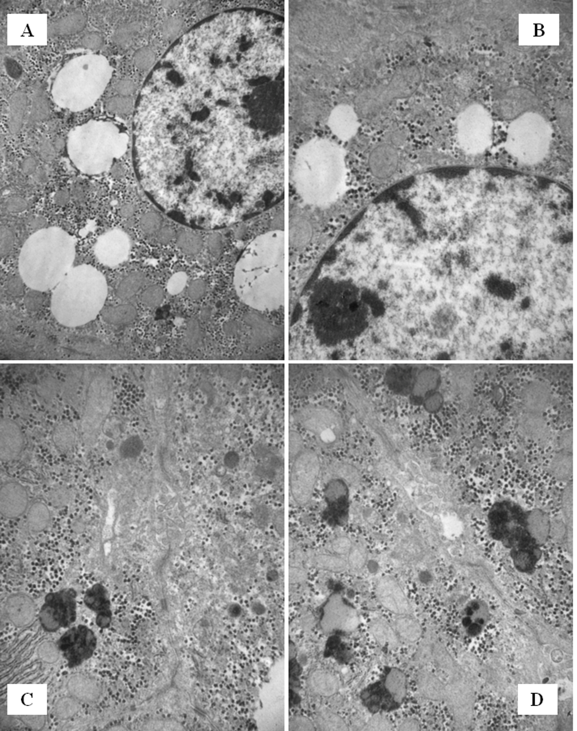

**0,7µm**

**0,7µm**

**0,7µm**

**Figure 6-SI.** Electron micrographs of liver samples after cold ischemia storage showing reduced Disse spaces (A: CS liver; B: NMP liver) and non-activated Kupffer cells (C: CS liver; D: NMP liver).

 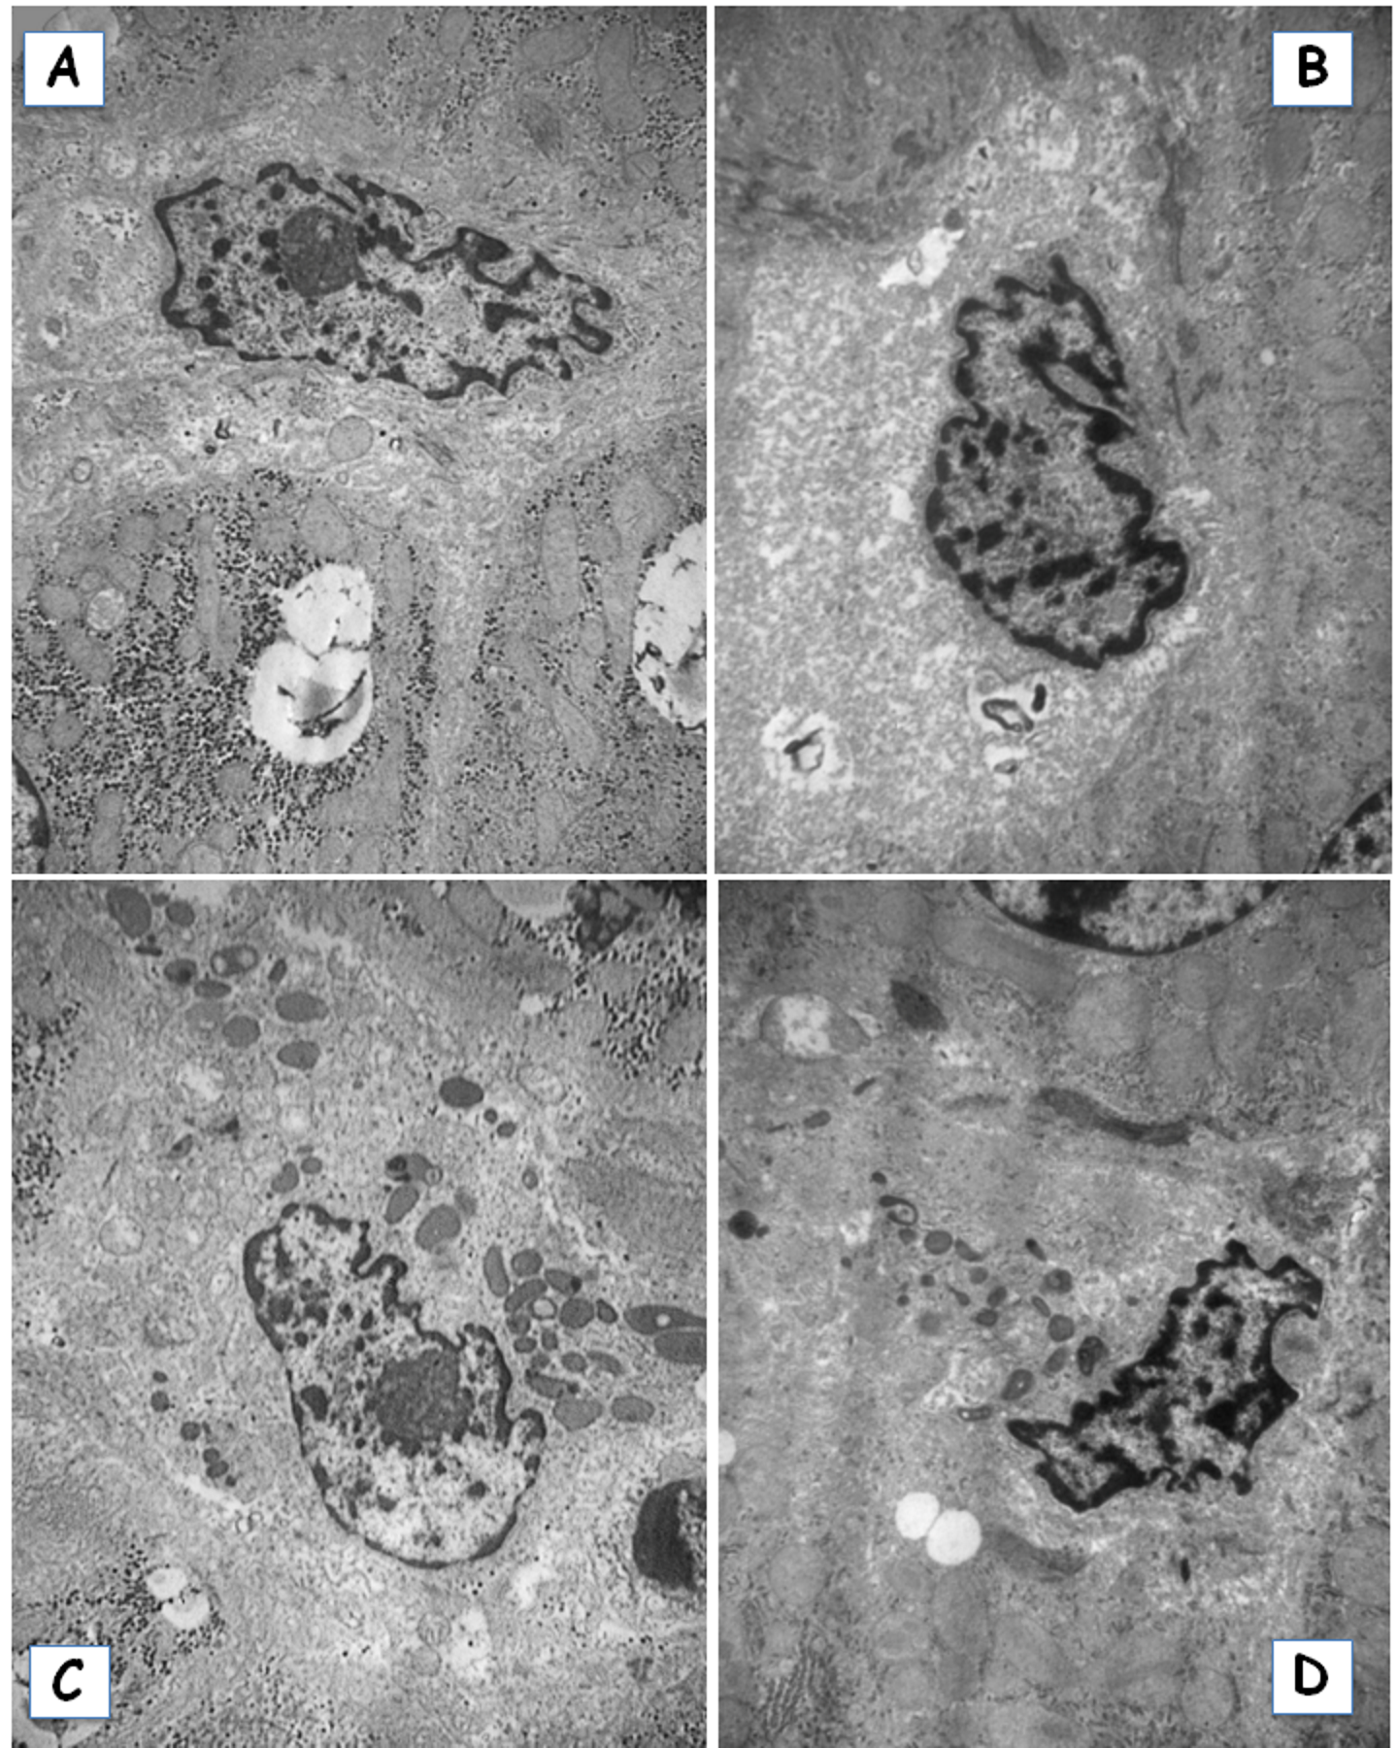

**Figure 7-SI.** Electron micrographs of CS liver samples 2 hours after implantation; (A, B) mitochondrial swelling; (C, D) lipid droplets.

 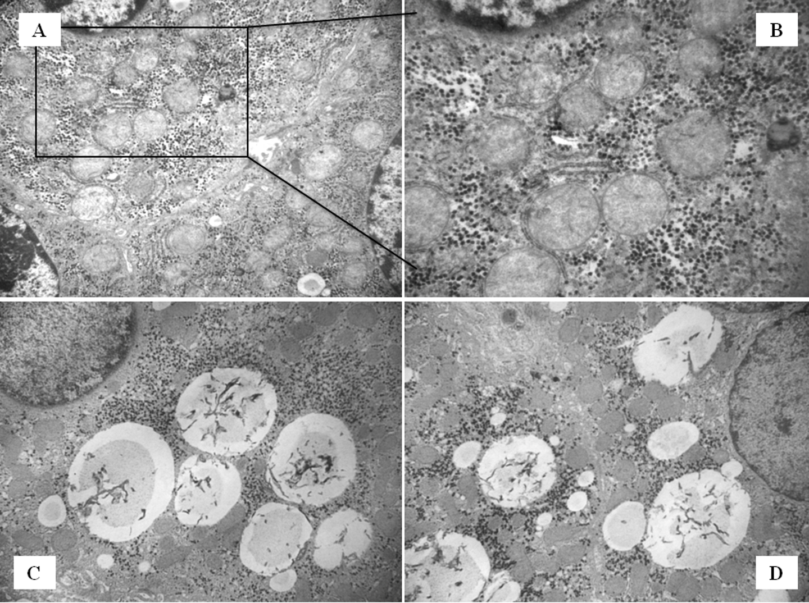

**0,45µm**

**Figure 8-SI.** Electron micrographs of CS liver samples 2 hours after implantation: (**A)** numerous dense bodies in the biliary pole; (**B)** damaged vessel; (**C)** activated Kupffer cell; (**D)** infiltrating neutrophil.

 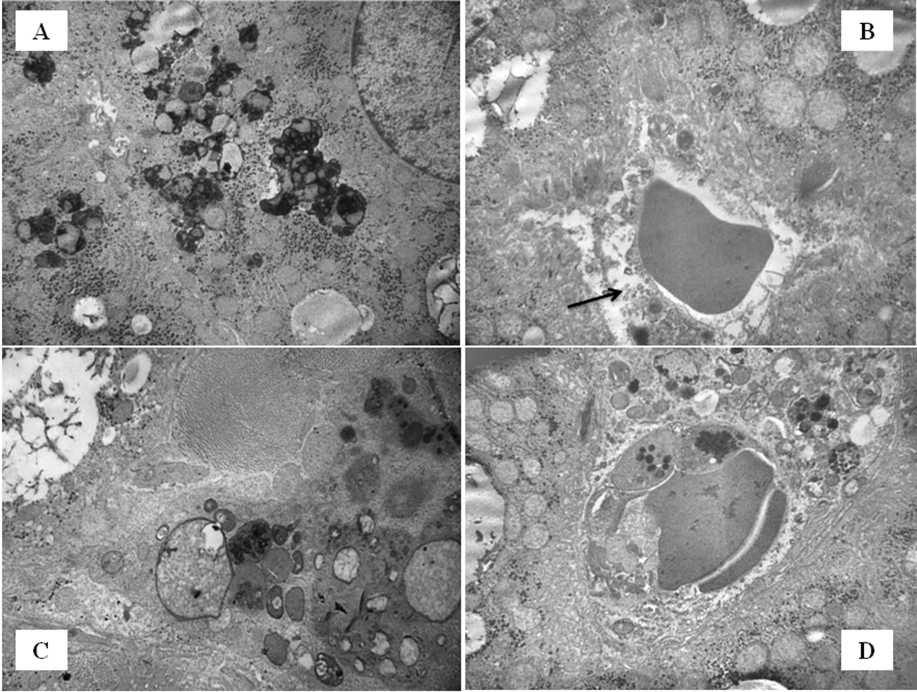

**Figure 9-SI.** Electron micrographs of NMP liver samples 2 hours after implantation. **A,B)** mitochondria of normal size; **C,D)** reduced lipid droplets.

 